Notable Alum - Extraordinary Cottey College Alumnae

Submitted by Bekah Odenwald,Chapter AX

January 2025

As leaders, influencers, and innovators in their fields, Cottey College students and graduates embody a commitment to leadership, a global perspective, and the creation of friendships and a network of strong women that last a lifetime. With their broad liberal education and willingness to take risks, alumnae build successful and fulfilling careers around the globe, while staying connected with other Cottey College alums and their local communities.

Chances are, you’ve heard of some alumnae. Talented Cottey College graduates have been and are at the forefront of countless industries—including law, science, medicine, business, politics, and the creative arts.

In law, there was Ruby Kless Sondock, a 1944 graduate, who was the first woman Texas Supreme Court justice, and Cindy Phlilips Acree, 1977, who served as a Colorado State Legislator. In medicine, Dr. Ann Marie Pendergast, 1977, the vice chair of Pharmacology and Cancer Biology at Duke. Cottey College alumnae have competed on Jeopardy! and Top Chef, served as Vice President of Communications for the Atlanta Falcons, Guest Experience Manager at Walt Disney World, and assistant general manager of the Associated Press.

We have US Treasurer, Fancine Irving Neff, 1946, actor Midge Boomgaarden McClosky, 1991, pilot, Aleta Jackson, 1967, who was the first woman to fly in a rocket-powered aircraft, and Miriam Stephens Kindred, 1951, the first woman stock broker at EF Hutton. The list goes on and on.

But today I am going to focus on five of the women Cottey College has given to the world.

**Jetta Carleton** was born on a farm in Nevada, Missouri, the daughter of P. A. Carleton, the local superintendent of schools. She had two sisters, Truma and Yana; both were schoolteachers, and over twenty years older than Carleton. The house in which they lived lacked indoor plumbing when she was born. Carleton attended Cottey College in Nevada, from which she graduated in 1933. She went on to study English and earn a master's degree at the University of Missouri. While there, she danced and acted in student productions, and in 1936 she was named the University of Missouri's Poet of the Year.

Upon graduation from the university, Carleton moved to Joplin, where she taught at Joplin Junior College. After a short time there she moved again, to Kansas City, where she took a job at WHB writing advertising copy; eventually she was given her own program on the station, focusing on local events. While living there she met Jene Lyon, and they married in 1943. They soon moved to New York City, where Carleton found work as an advertising copywriter, among a variety of other odd jobs. The couple purchased a house in Hoboken, New Jersey, but returned to Nevada for two weeks every summer. It was these visits which provided the inspiration for her novel *The Moonflower Vine*.

*The Moonflower Vine* was published by Alfred A. Knopf and proved to be a sensation. It was edited by Robert Gottlieb, who said of it, "Of the hundreds upon hundreds of novels I've edited, this is literally the only one I've reread several times since its publication." The novel spent four months on the New York Times bestseller list; it was selected for promotion by two major book clubs, appeared as a Reader's Digest Condensed Book, and was published in eight other countries.

Carleton and her husband moved to Santa Fe, New Mexico and opened a publishing house with the money earned from her novel. They published poetry, cookbooks, and works on regional history, which kept her too busy to write. During this time she continued with her tradition of visiting family in Nevada every summer. The press folded in 1991 and Carleton began work on another novel, The Back Alleys of Spring, based on her experiences teaching in Joplin. She had nearly finished it in 1997, and was preparing to shop it around for publication when she suffered a stroke which ultimately robbed her of her ability to speak. At her death in 1999 her papers went to a nephew in Missouri and the novel was thought lost in a May 2003 tornado, but it had instead been preserved by her literary executor, Larry Calloway, in Santa Fe. The Back Alleys of Spring was eventually published in 2012, under the title *Clair de Lune.*

Another notable Cottey alum is **Marilyn Harris**. Harris was an American author best known for her seven-novel "Eden" series, an historical saga about the Eden family of England. She is also the author of the best selling novel, Hatter Fox.

Harris was born on June 4, 1931, in Oklahoma City, Oklahoma, the daughter of John P., an oil executive, and Dora Harris. Harris was educated at Cottey College from 1945 to 1951, then transferring to the University of Oklahoma, from which she received a bachelor of arts degree in 1953 and a master of arts degree in 1955.

Harris's first collection of short stories, King's Ex, was published by Doubleday in 1967. After that Harris proved a prolific author, publishing twenty books, including novels, short stories, romance/historical fiction and children's fiction in a twenty-year period. The novel Hatter Fox was successfully filmed as a TV movie under the title The Girl Called Hatter Fox starring Ronny Cox and Joanelle Romero as Hatter Fox. The film marked the first time a Native American actress played a leading role. Harris's work received a wide readership; in 1983, nine million of her books were in print, and her work has been translated into many languages, including French, German, Spanish, Portuguese, Polish, and Japanese. She was also an author in residence at Oklahoma's Central State University.

Among the awards Harris received are the O. Henry Award for her début short story Icarus Again, the University of Oklahoma Literary Award, the Lewis Carroll Shelf Award, the Oklahoma Federation of Writers Teepee Award, the Women in Communications By-Liner Award, and the Oklahoma Writers Hall of Fame Award.

**Grace Layton** had just finished her freshman year at Cottey College when she was stricken with polio. It was 1950, five years before the polio vaccine, and the disease was merciless, leaving her a quadriplegic. She was in an iron lung for several months and in hospitals for a year.

Her memoir *Brimming Over* tells the story not only of her disease and the painful, frightening short-term recovery, but of the life that unfolded after the disease. Although confined to a wheelchair, Layton went on to marry and adopt nine non-white children, each with a physical or emotional handicap. The book recounts the early efforts of her and husband Dave Sandness to establish independence, of the greeting card business she established by drawing charcoal illustrations using her mouth, of several moves the family made around the country, and of the trials, tribulations and joys of raising nine children, each with their own distinct personality.

*Brimming Over* challenges the reader's attitudes toward racial discrimination, people with disabilities, and overcoming hardship. Layton and her family were featured on the "Today" television program. She received many awards including North Dakota Outstanding Handicapped Citizen and Mother of the Year from the National Mother's Day Committee.  
  
**Judith McCulloh** was an American folklorist and university press editor.

McCulloh was born in Spring Valley, Illinois, on August 16, 1935 to Henry and Edna Binkele. All four of her grandparents were from Germany. Her father worked for the railroad in Spring Valley, and the family later moved to Peoria, Illinois. She grew up at Northmoor Orchard, not far from Peoria, where her parents had bought an apple orchard and sold apples and cider.

She studied at Cottey College, Ohio Wesleyan University, and Ohio State University. The summer before she was to travel to Europe on a Fulbright Fellowship, she attended a Folklore Institute at Indiana University for several weeks. She stated that event was "the most exhilarating experience" she had ever had, and influenced her decision to not continue her studies at OSU but instead to enroll in Indiana's folklore program. In 1970, she earned her Ph.D. in folklore from Indiana University, with minors in anthropology and linguistics. Her dissertation was a text tune study of the lyric folk song "In the Pines" and the 160 variants and arrangements of the song created up to that time. While at Indiana University, she worked as an assistant in the Archives of Traditional Music and was an assistant to the editor of the journal Folklore and Folk Music Archivist.

In 1972, she began working as an assistant editor at the University of Illinois Press, where she continued to work for 35 years until her retirement. Her positions at the Press also included executive editor, assistant director, and director of development. In her first year at the Press, she launched and was the editor of the acclaimed Music in American Life book series. She also created the University of Illinois Press series Folklore and Society, and was instrumental in the 1983 launching of the scholarly journal American Music.

Music in American Life was the first book series devoted to the study of music in the United States. Critics noted the series "began issuing path-breaking studies shaped by the fields of folklore, English literature, and labor history, before American music had become a subject in the academic curriculum, and it had a profound effect on shaping the emergent field". Under McCulloh's editorship, 130 titles were published in the Music in American Life series and 20 of them earned Awards.

McCulloh served on the board of trustees of the American Folklife Center at the Library of Congress, two terms as the AFC chair, was named AFC trustee emerita in 2004, and also president of the American Folklore Society. Her books include *Stars of Country Music, Ethnic Recordings in America,* and *Folklore/Folklife.*

Among her awards and honors are the Fulbright Fellowship, the Society for American Music Distinguished Service citation, the International Country Music Conference Lifetime Achievement Award, and the National Endowment for the Arts, National Heritage Fellowship, which is the United States government's highest honor in the folk and traditional arts.

**Carol Sue Littleton** is an American film editor. Her work includes Body Heat, E.T. the Extra-Terrestrial, The Big Chill, Places in the Heart, Silverado, The Accidental Tourist, and Wyatt Earp. She won the Primetime Emmy Award for the ABC movie Tuesdays with Morrie, and she was nominated for the Academy Award in Film Editing for her work on E.T. In 2023 she received the Academy Honorary Lifetime Achievement Award.

Carol Littleton was born 1942 in Oklahoma City. After completing her studies at Cottey College in 1962, she attended the University of Oklahoma College of Arts & Sciences, obtaining her bachelor's and master’s degrees.

In the late 1980s, Carol Littleton was elected to and has since served as both the president and vice president of the Motion Picture Editors Guild. Littleton has been elected as a member of the American Cinema Editors, and has served as ACE vice president since 2019. She is also a current member of the board of governors of the Academy of Motion Picture Arts and Sciences (Film Editors Branch). Critics have stated, "Littleton's career in film editing serves as a model for those who come after her”.

These are just five reasons why P.E.O. champions Cottey College. As you can tell from this short list, with their exceptional lives and achievements, Cottey College alumnae have given much to the world. Countless people in many walks of life have benefited from their gifts. And the most exciting thing is that right now, at Cottey College, there are over 300 young women, honing their skills and passions, preparing to share their gifts with generations to come.

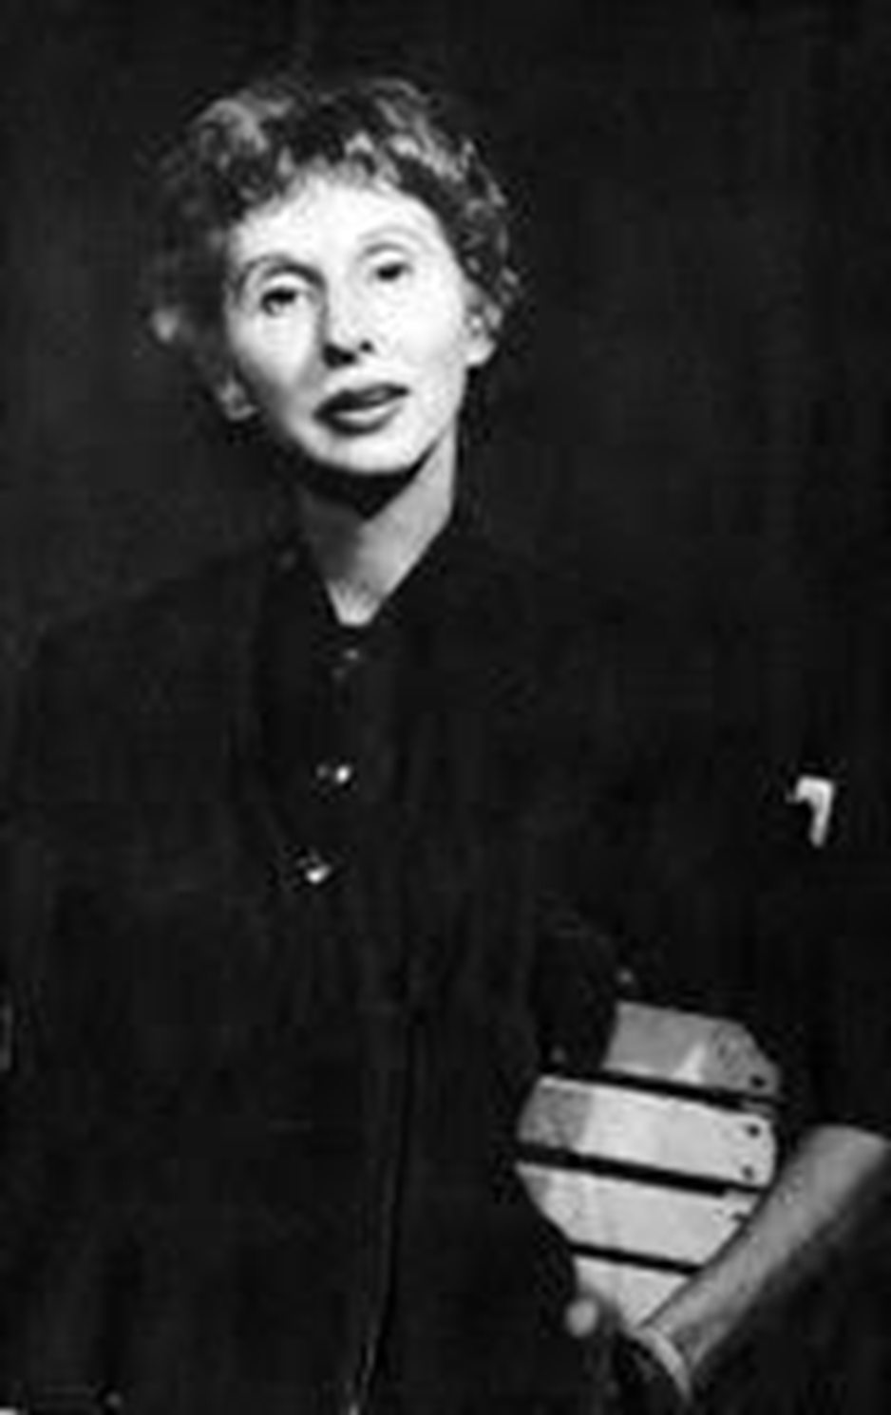 Jetta Carleton

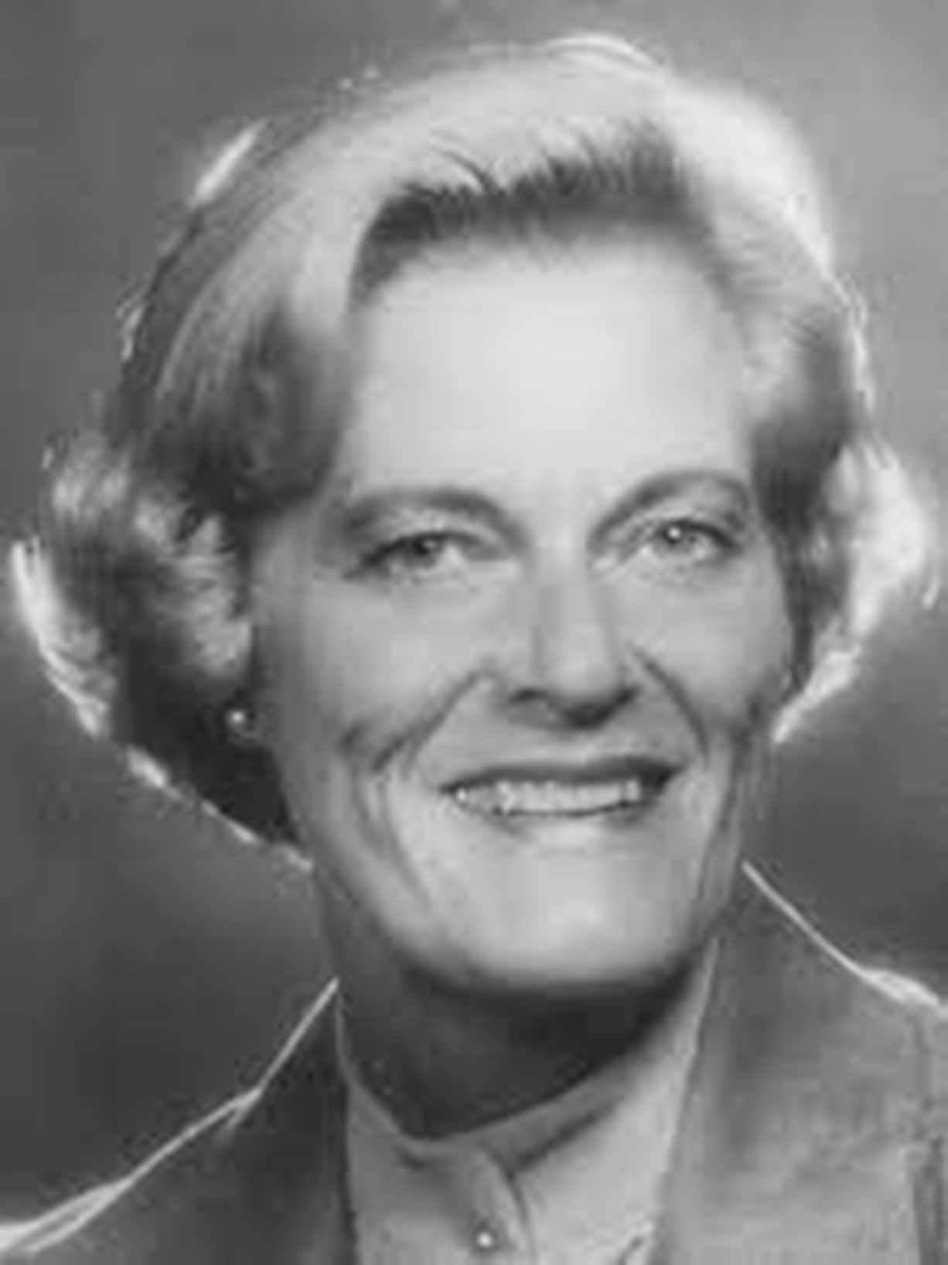

Marilyn Harris

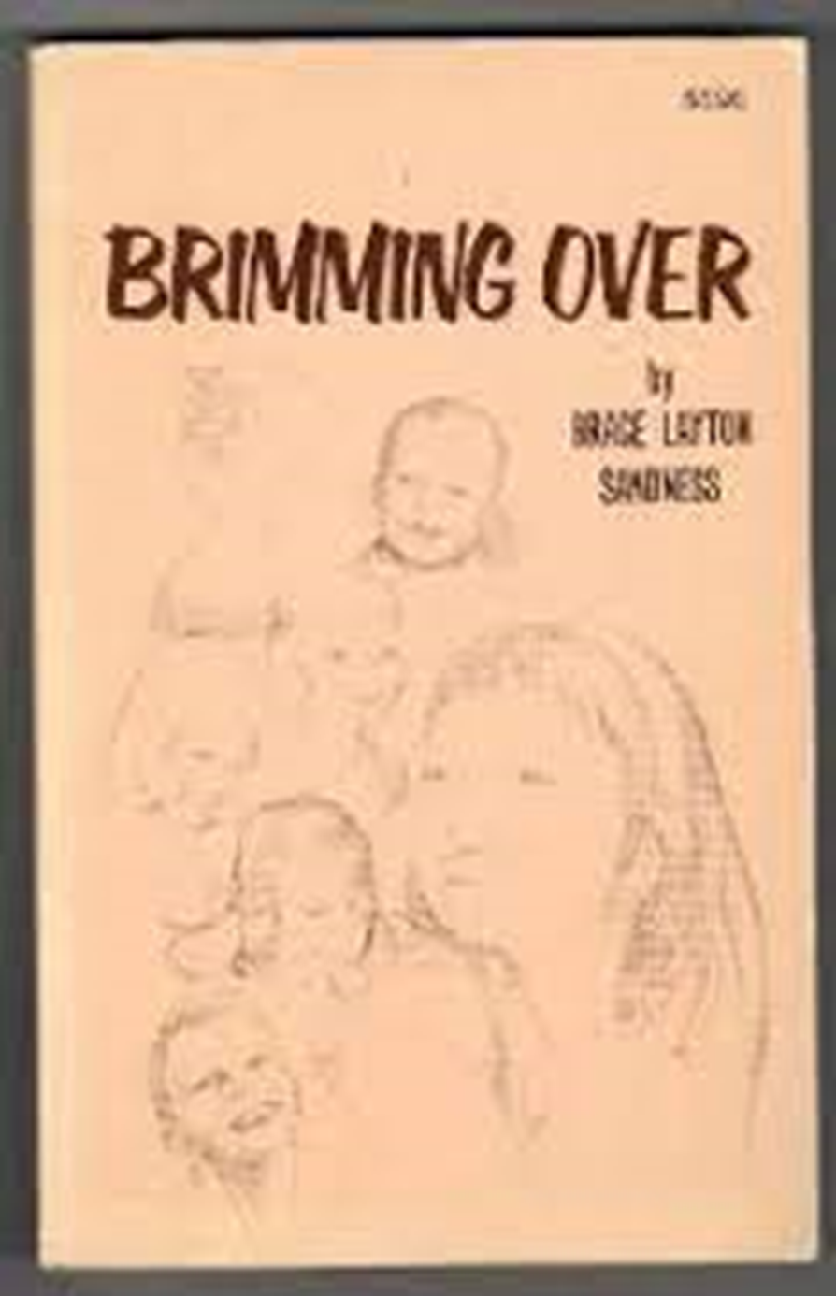

Grace Layton

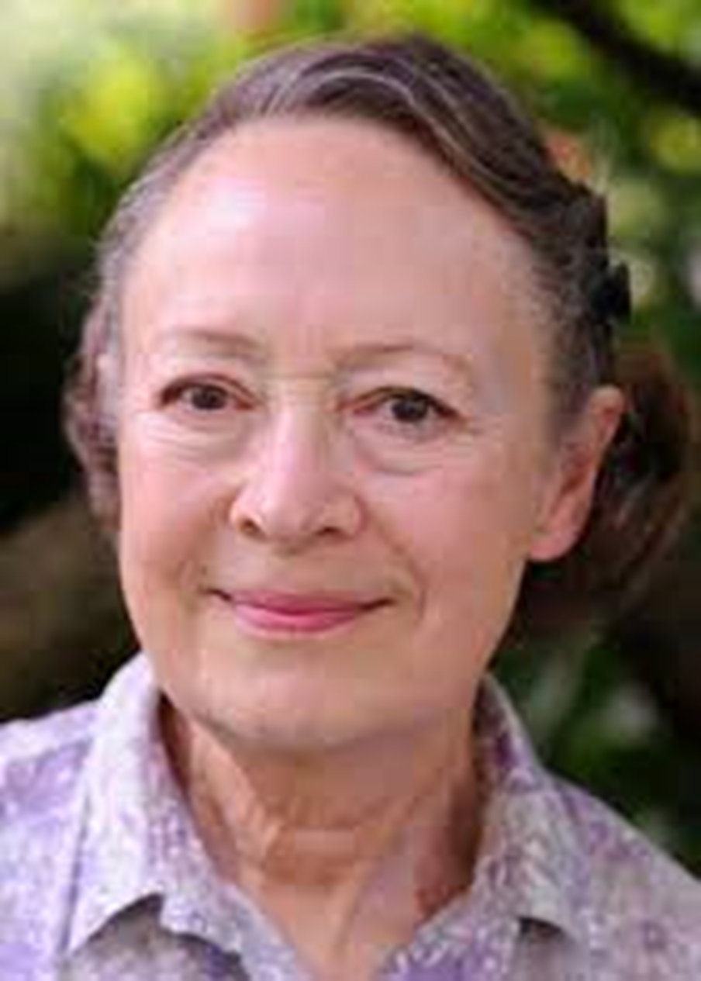

Judith McCulloh

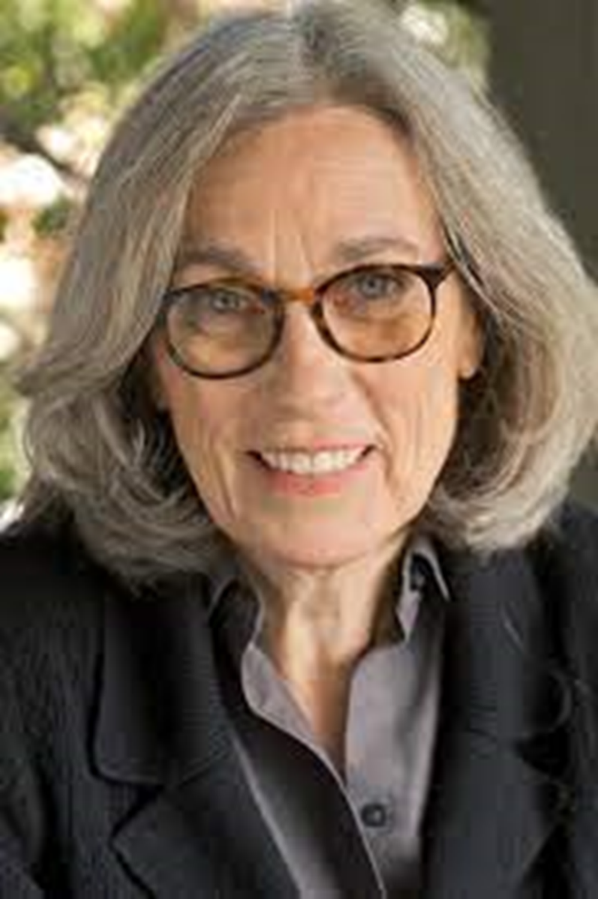

Carol Littleton